Complete the following questions in an MS Word document format only. Save the final file in the format of "Week 6 Written Homework_YourFullNameHere.doc". Turn it into Digital Drop Box (Don't use email attachment or copy and paste into Drop box)
1. Speeding Tickets
Each police officer may issue speeding tickets to motorists in an assigned area. Originally, the attribute date was modeled as part of the SPEEDING TICKET entity. However, the city police department wants to see if there is a relationship between weather and the frequency of speeding tickets -- do people drive faster on nice sunny days? Are there more tickets in hot weather or cool weather?
Modify the ERD to address this new requirement.
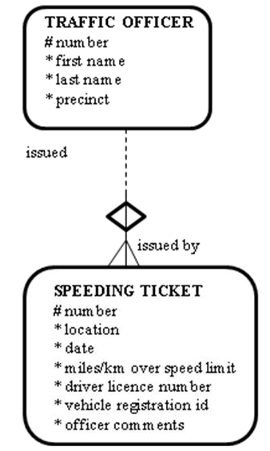

2. Comic-book collectors need to know the price history of different types of comics. This helps them decide what to purchase/collect and how much to sell their collection for.
Create an ERD (two or three entities) to model this.
3. When a student’s grade is changed, we need to record information on the teacher who changed the grade and the reason for the change.
Start with the ENROLLMENT entity, which is the resolution of the M:M between STUDENT and CLASS.
4. Examine the following table, and answer the following questions:
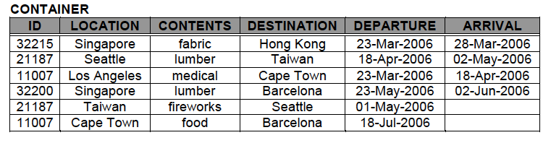
a. List 2 ways this data could be used to provide useful information to the shipping company (2 reports that could be made using the data)
b. Based on the business rules inferred from the table, identify one piece of data that must be in error.
c. Based on this data, how many containers were in transit on April 10th?
d. Where was container 32200 on June 1, 2006?
e. Assuming no gaps in the data, where was container 11007 on July 1, 2006?
f. What were the contents of container 11007 on April 1, 2006?

